CSC 427 Numerical Analysis

CSC 427 Numerical Analysis

Numerical Methods: Algorithms used to obtain numerical solutions of a mathematical problem.

Analytical Methods: Using the exact formula to present solutions to a mathematical problem.

Not all equations have exact or fixed formulas, so algorithms can be developed to determine its solution.

Numerical Methods can be used when…

     Analytical solutions are difficult to obtain or difficult to practice.

     Analytical solutions do not exist for that problem.

Basic Needs in numerical analysis

Practical: Can easily be computed in a reasonable amount of time.

Accurate: Should be close(approximate) to its true value.

Information about the approximate error. (Should be able to determine the margin of error or deviation from its true value).

Some simple Non-linear equations can be solved using the quadratic formula (Almighty formula)



Ex of simple non-linear equation is 

Some have no analytical solutions

Ex.

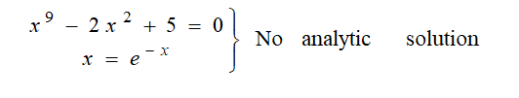

There are no exact formulas that can be used to solve such equations; numerical methods must be used in this situation.

There are three methods for solving such Nonlinear equations

Bisection Method

Newton-Raphson Method

Secant Method

We can also see that although it is much easier to solve linear equations with analytical solutions, problems arise when we have more than two unknown variables and when we have a thousand unknown variables, it becomes a challenge.

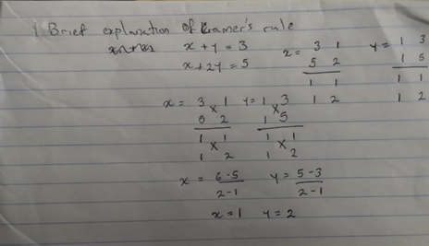

Just from reasoning, Cramer’s rule will obviously not be able to support large problems.

There are three methods for solving systems of Linear equations.

Naïve Gaussian Elimination.

Gaussian Elimination with Scaled Partial     Pivoting.

Algorithm for Tri-diagonal equations.

Curve Fitting

It means constructing a cuve that best fits the data points.

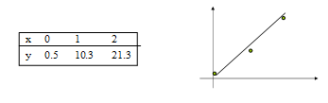

 Data on the left, the line/curve on the right

Curve fitting also means showing the relationship between two variables (in this case x and y) constructing a curve that fits the data.

Interpolation

*Using known values to determine unknown ones that fall between*

Process of estimating unknown values that fall between known values.

Method of Curve Fitting

1. Least Square Method

      Linear Regression

      Non Linear Least Square Problems

      2.  Interpolation

  1. Newton Polynomial Interpolation

2. Lagrange Interpolation

Integration

Summing up parts of a function to find the whole.

    Some functions can be solved analytically

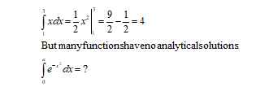

Methods of Numerical Integration

1. Upper and Lower Sums
2. Trapezoid Method
3. Romberg Method
4. Gauss Quadrature

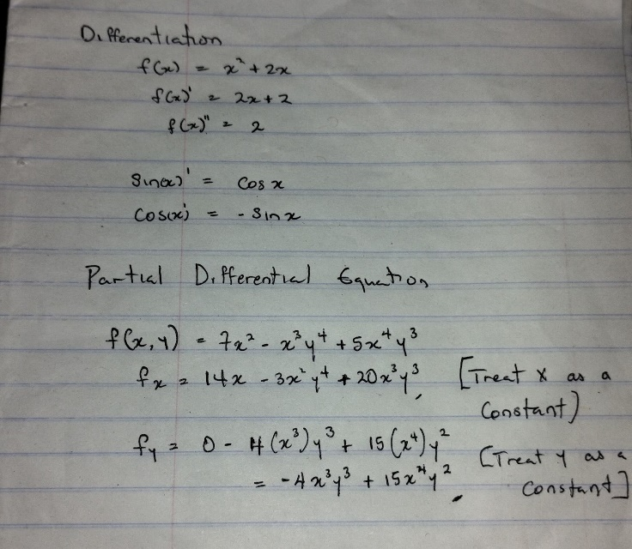

Look Into Ordinary Differentiation and Partial Differentiation a little

Chapter 2:

Number Representation

Real Numbers:  Any number that can be plotted on the number line. (If you don't know what a number line is, Google it 😁).

All numbers are real numbers

Types of real Numbers

Rational Numbers

Irrational Numbers

Fresh Reminder

1. Natural Numbers --- 1, 2, 3, 4, 5, 6 ….. Zero, negative and decimal numbers are not natural Numbers.
2. Whole Numbers--- They are natural numbers but zero is Included. 0, 1, 2, 3, 4, 5 ….
3. Integers --- Also include negative natural numbers -3, -2, -1, 0, 1, 2, 3, 4, ….
4. Rational numbers: Includes all integers as well as fractions and decimals that can be expressed as fractions. That means the numerator and denominator of the fraction must be integers and the denominator is not 0. Ex. 2/3, 3.12, 0.4, -8.

Integers, whole numbers and Natural numbers are all rational numbers.

1. Irrational numbers:  Never ending set of numbers that don’t repeat with a constant decimal(when the numbers are not repeating). Ex. π, √2, √3, √5, 1.45213929

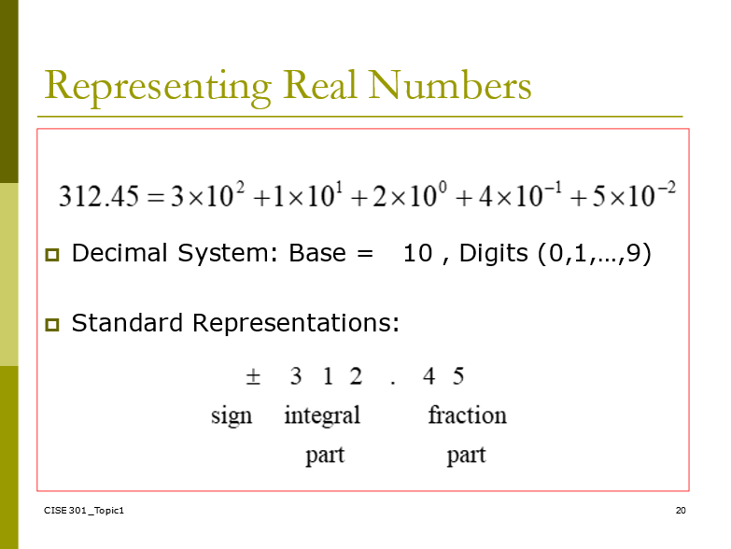

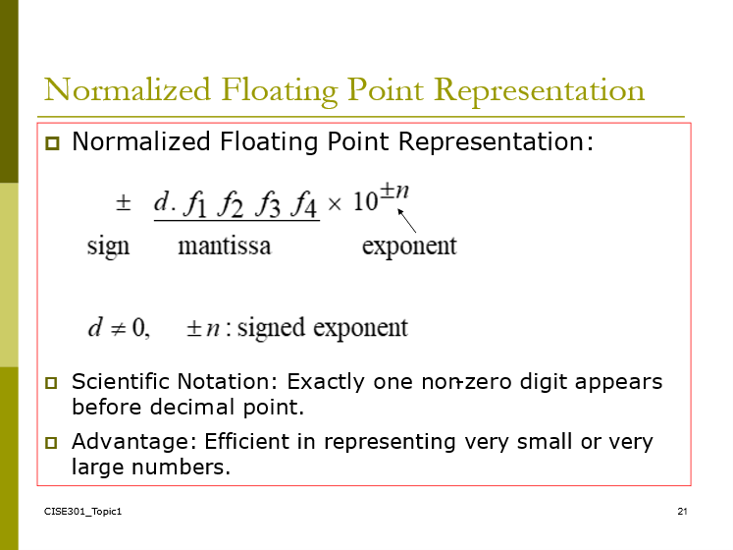

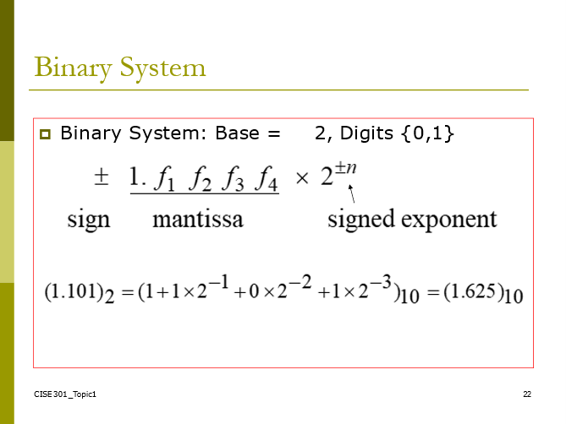

SELF EXPLANATORY

Some numbers that can be represented in one binary system can be infinite and difficult to represent in another binary system.

1.1 in base 10 gives an infinite value in base 2.

IEEE floating point???

Significant digits are those digits that can be used with confidence.

Single-Precision: 7 Significant Digits

  1.175494… × 10-38 to 3.402823… × 1038

Double-Precision: 15 Significant Digits

  2.2250738… × 10-308 to 1.7976931… × 10308

Some Notes

pNumbers that can be exactly represented are called machine numbers.

p

pDifference between machine numbers is not uniform

p

pSum of machine numbers is not necessarily a machine number

Accuracy and Precision

Accuracy: It is related to the closeness to the true value

Precision: It is related to the closeness to other estimated values

 Precision doesn’t mean it’s right

If the weather prediction for tomorrow is taken ten times and all results fall between 32-33.5 degrees, that does mean it is accurate, but it is precise. Let’s say the temperature ends up being 26 degrees. It is definitely not accurate. But if the predictions were closer to 25 degrees, we could say it’s accurate.

Rounding: means to replace the number by the nearest machine number.

Chopping: Throw away all extra digits

No offense, these are not concrete definitions

Error Definition: True error can only be computed if the true value is known.

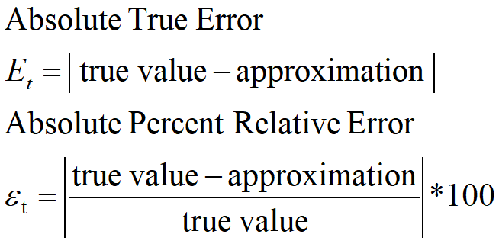

Error = True value - approximation

Easy enough to understand

If you are supposed to collect change of 500 but received 400

Error = True Value - approximation

      500    -    400

Error = 100

Absolute Percent Relative error =  100/500 * 100 = 0.2  * 100 = 20%

Estimated error: This is when the true value is not known. When this is so you compare your current estimate with your previous estimate.

Say you're trying to calculate y+our money in bitcoin but don’t know the current value(but you know the price has gone up or down). Previous estimate can be the previous value while the current estimate is what you think the value currently is.

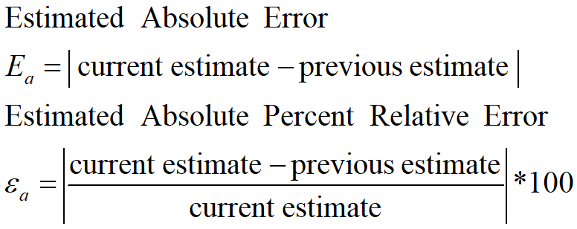

We say that the estimate is correct to *n* decimal digits if:

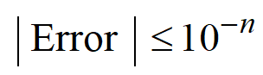

We say that the estimate is correct to *n* decimal digits **rounded** if:

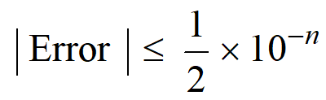

**Taylor Theorem**

If you want to learn about it, visit:

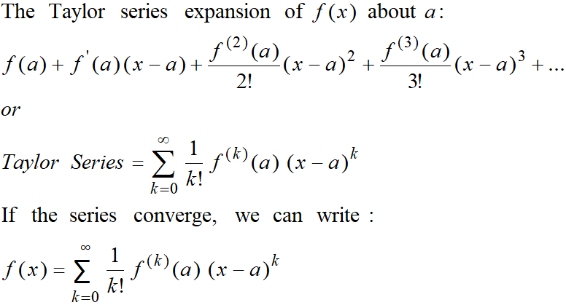

Maclaurin series

The Maclaurin series is a special case of the Taylor series with the center of expansion *a* = 0.

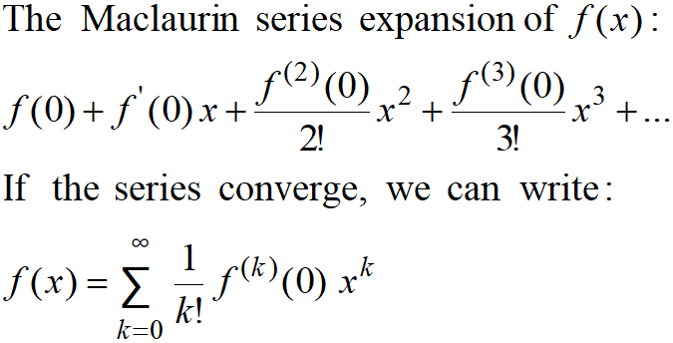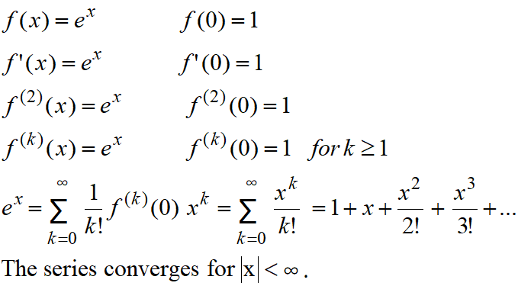

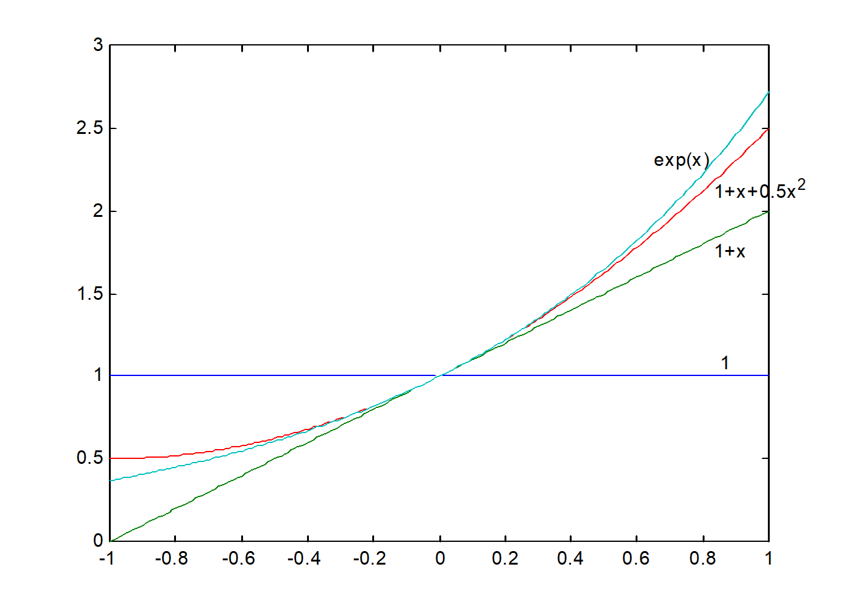



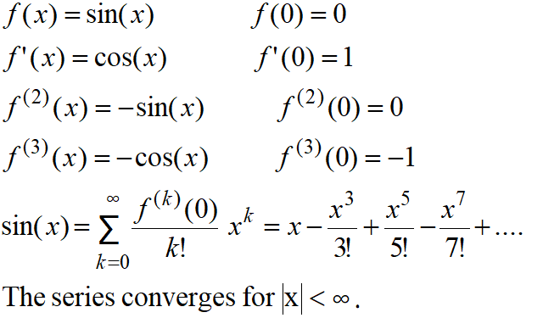



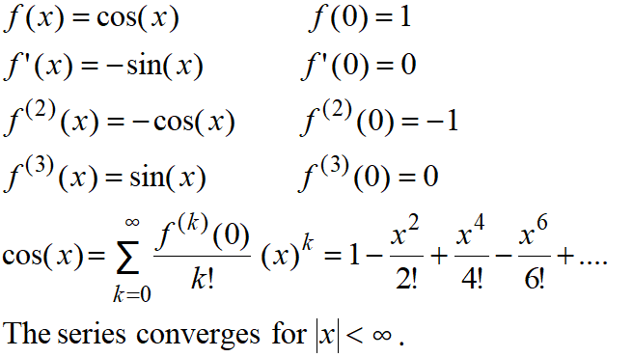

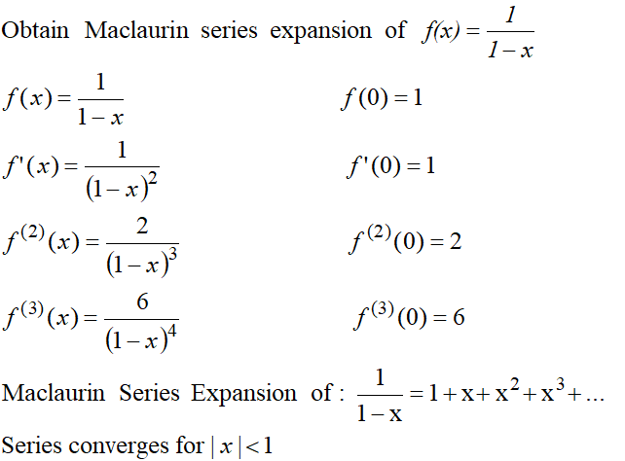

Can we apply the series for x≥1??

How many terms are needed to get a good approximation???

  These questions will be answered using Taylor’s Theorem.

Taylor Series

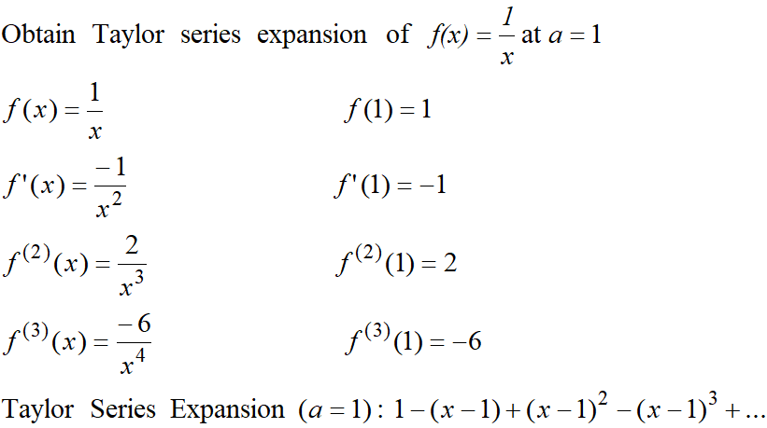

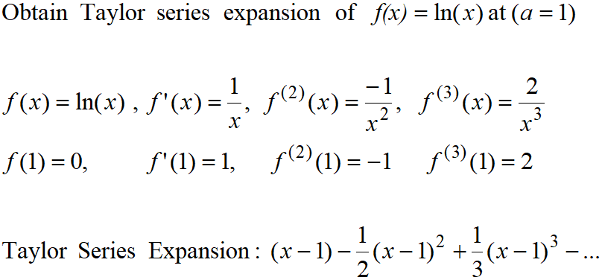

Taylor Series

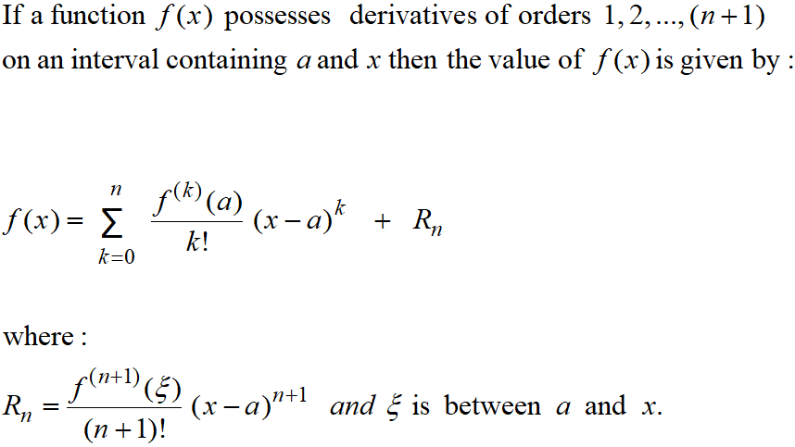

If you want to learn the Taylor series and Maclaurin Series, check it out here.

[Taylor Series and Maclaurin Series - Calculus 2](https://www.youtube.com/watch?v=LDBnS4c7YbA)

[**Oxford Calculus: Taylor's Theorem Explained with Examples and Derivation**](https://www.youtube.com/watch?v=DULzJmUHN5g)

**Mean Value Theorem**

[**Mean Value Theorem**](https://www.youtube.com/watch?v=SL2RobwU_M4)

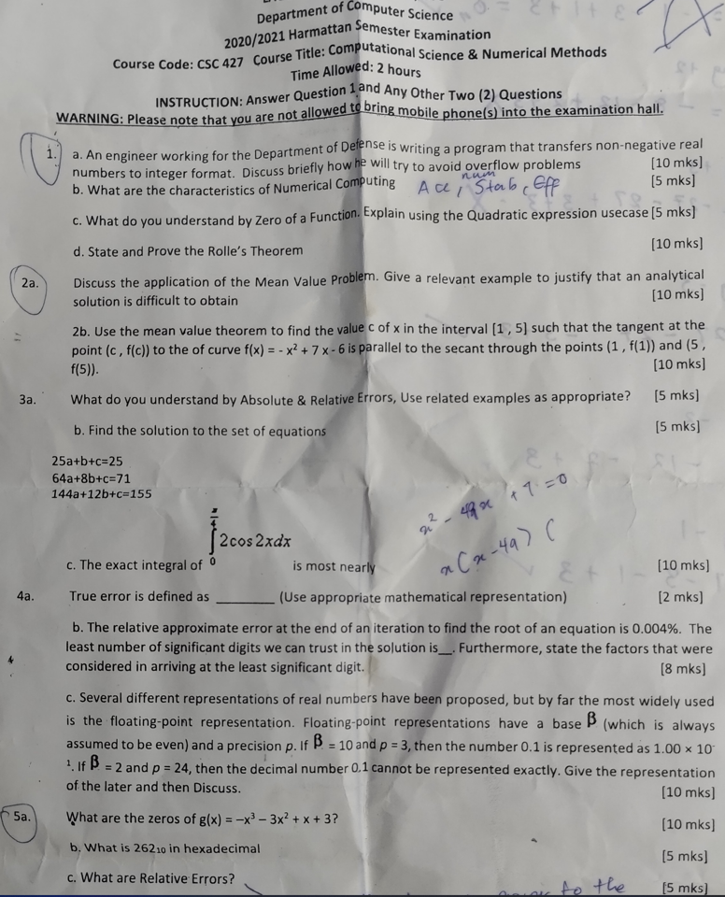

Solution

1. A. To avoid overflow problems, the maximum nonnegative integer can be represented in a 5-bit integer word.

B.  **JUST A GUESS**

Characteristics

* It should not be easily solved by analytical methods.
* It should be an equation that’s difficult or impossible to solve.
* It is used for equations with no formula.
* Numerical method only uses evaluation of standard functions and the operations: addition, subtraction, multiplication and division.

C. The zeros of a function are **the values of x when f(x) is equal to 0**.

To find the zeros of a quadratic function, we equate the given function to 0 and solve for the values of x that satisfy the equation. Here are some important reminders when finding the zeros of a quadratic function:

* Make sure the quadratic equation is in standard form (ax2 + bx + c = 0).
* Factor whenever possible, but don’t hesitate to use the quadratic formula.
* A quadratic function can have at most two zeros.

D. Rolle's theorem states that **if a function f is continuous on the closed interval [a, b] and differentiable on the open interval (a, b) such that f(a) = f(b), then f′(x) = 0 for some x with a ≤ x ≤ b**.

2a.

3a. The relative error is defined as the ratio of the absolute error of the measurement to the actual measurement.

Relative error = (x0-x)/x = (Δx)/x  --------------------------- x is the actual value, x0 is the measured value.

Absolute error is the difference between a measured or inferred value and the actual value of a quantity.

Might be the same with true error.

Related examples….

For example, if a scale states 90 pounds but you know your true weight is 89 pounds, then the scale has an absolute error of 90 lbs – 89 lbs = 1 lbs.

Relative error = (x0-x)/x = (Δx)/x = absolute error/actual value =  1/89 = 0.01123595505

3b

.

3c.

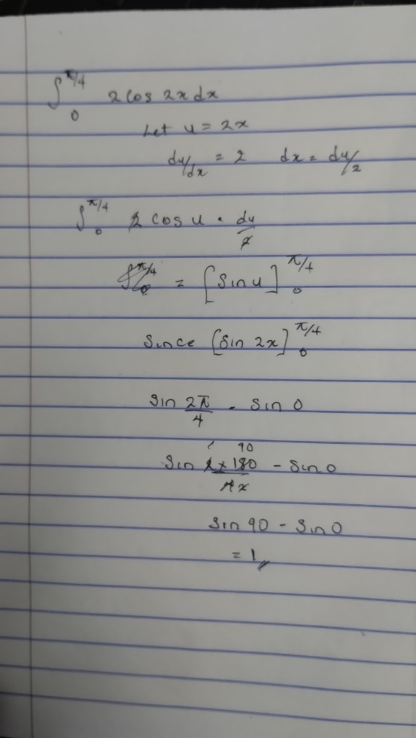

4.  The True Error is defined as the difference between true value and observed value

4b.

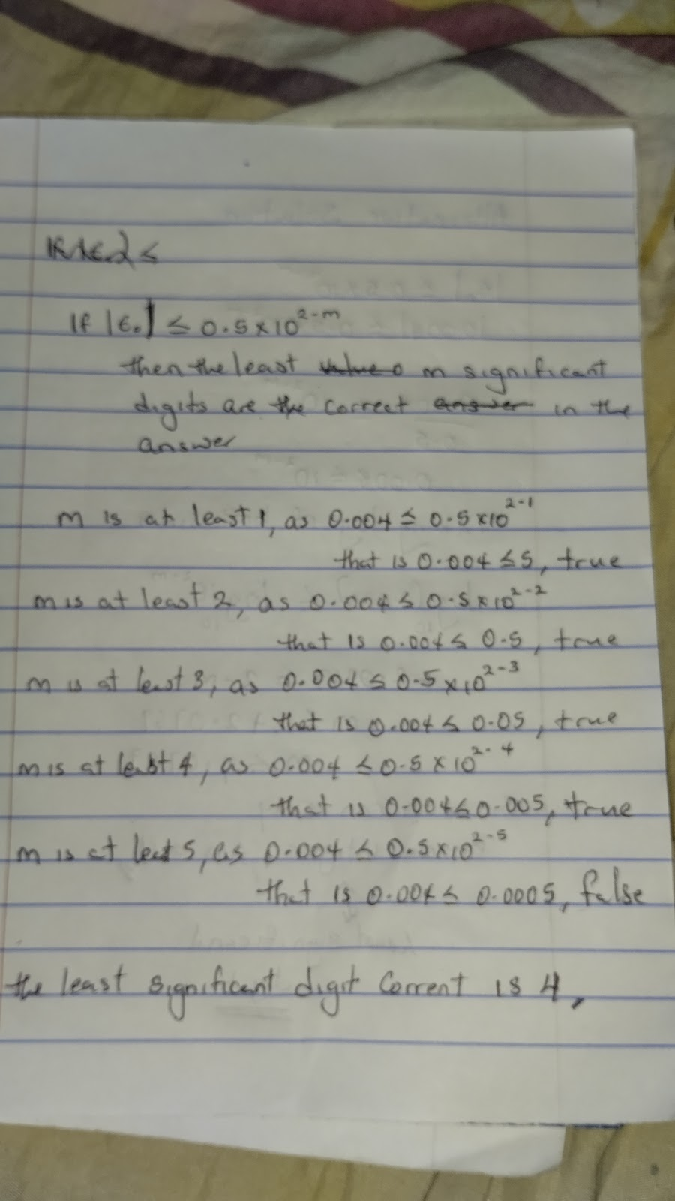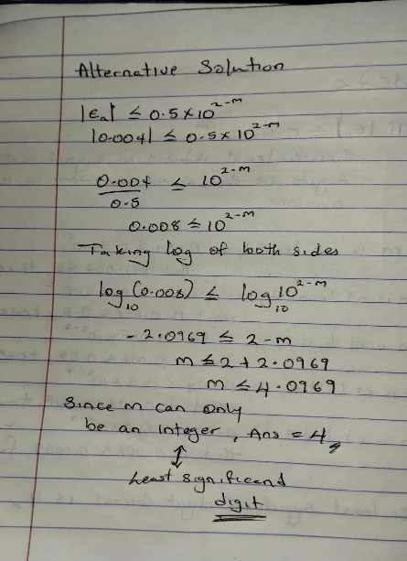

5a.

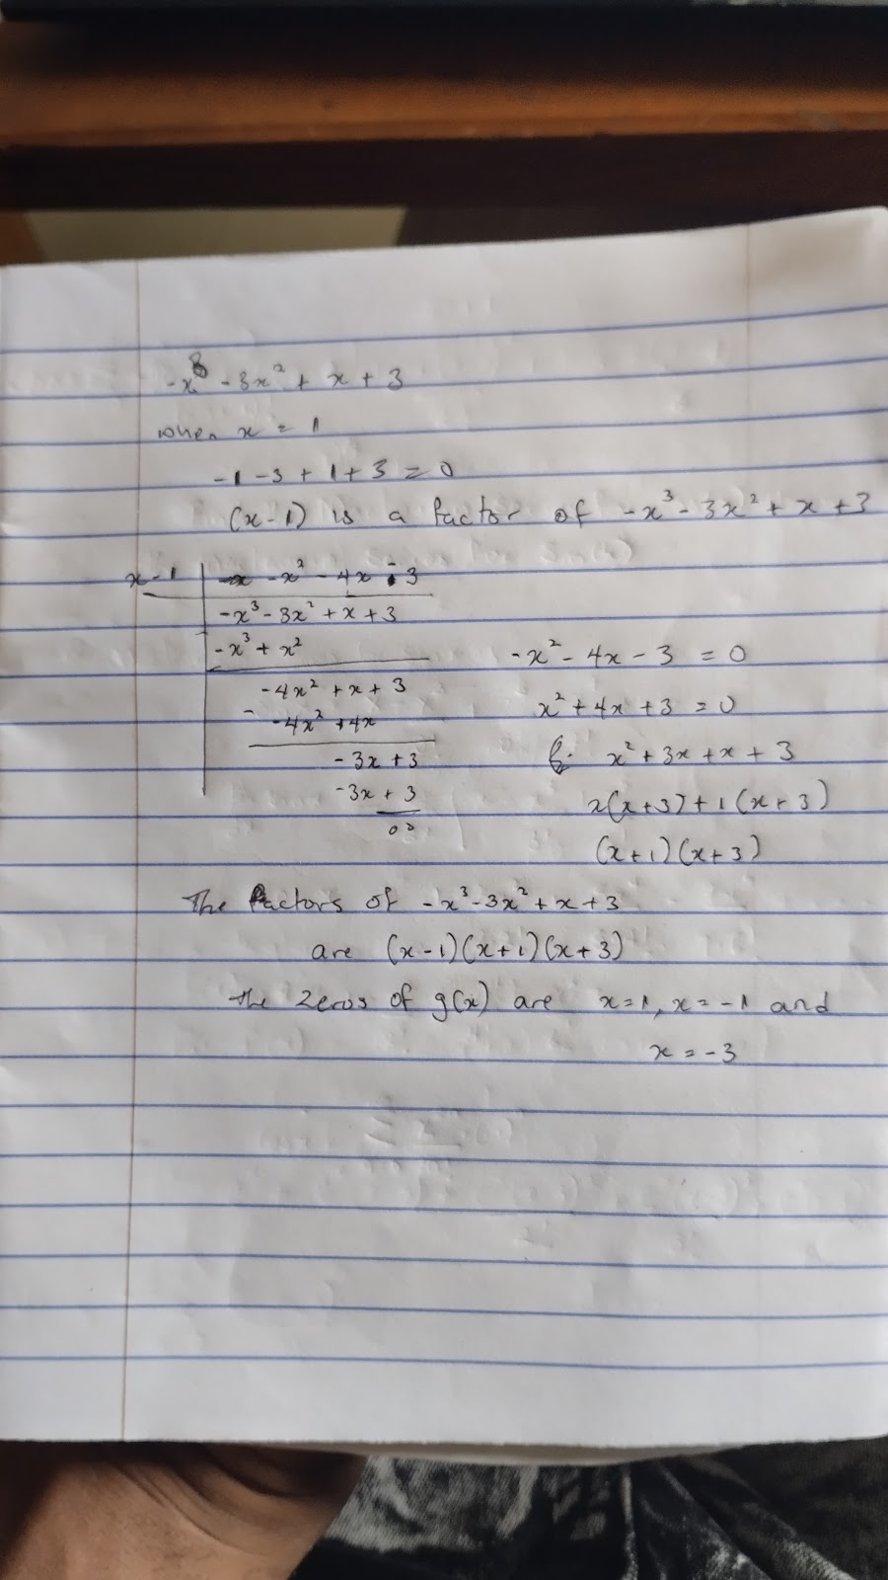

B.

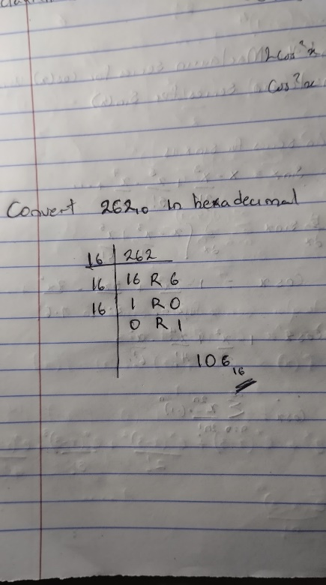

C. The relative error is defined as the ratio of the absolute error of the measurement to the actual measurement.

Relative error = (x0-x)/x = (Δx)/x  --------------------------- x is the actual value, x0 is the measured value.